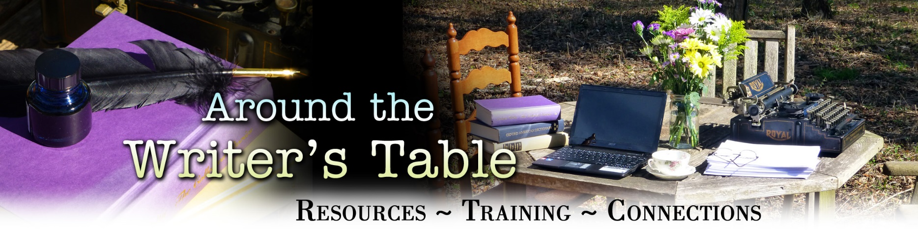

Creating Your Author Mission Statement

An Author Mission Statement is a declaration of your long-term intentions as a writer. It creates focus and direction for all your writing efforts, whether they are career-motivated or for personal enjoyment or gratification. Your Statement will keep you concentrated on work that serves you; it will keep your writing aligned with the way you want the world to see you and what you want to leave behind. Your Author Mission Statement defines your “why” for writing.

Use this form to record your responses to the following questions. This worksheet is for your eyes only, so be objective and honest with yourself. Refer back to your answers as you build your Mission Statement in the last section of this worksheet. The text fields are designed to expand as you fill them, so write as much or as little as you’d like.

A. Form and Genre
1. In what general form(s) do you currently write/want to write?

☐ Journaling/Diary, personal writing (answer Question 2 then skip to Section B)
☐ Short Fiction, such as Flash Fiction, Short Stories, Novellas, and Children’s Books
☐ Long-form Fiction, Novels
☐ Short Nonfiction, such as Essay, Articles, Blog Posts
☐ Long-form Nonfiction, such as self-help, memoir, biography, etc.
☐ Poetry
☐ Other: Click here to enter text.

2. What form(s) might you want to explore in the future?

☐ Journaling/Diary, personal writing
☐ Short Fiction, such as Flash Fiction, Short Stories, Novellas, and Children’s Books
☐ Long-form Fiction, Novels
☐ Short Nonfiction, such as Essays, Articles, Blog Posts
☐ Long-form Nonfiction, such as self-help, memoir, biography, etc.
☐ Poetry
☐ Other: Click here to enter text.

3. In what genre(s) do you write/want to write? The following are just a few of the major genres in fiction and nonfiction, and several are grouped to keep the list from being extensive. There are many subsets. If you are unsure which genre your work might be, explore your library or local bookstore to find writing similar to yours. Wikipedia also has an extensive list: https://en.wikipedia.org/wiki/List_of_writing_genres.

Fiction:
☐ Children’s Picture Books
☐ Crime/Detective
☐ Fantasy, Fairy Tale, Fable, or Magical Realism
☐ Historical Fiction
☐ Horror, Suspense, Thriller
☐ Humor
☐ Literary
☐ Mystery
☐ Western
☐ Middle Grade or Young Adult
☐ Other
Nonfiction:
☐ Biography
☐ Essay
☐ Journalism/News
☐ Memoir
☐ Self-Help
☐ Narrative Nonfiction/Personal Narrative
☐ Reference Book, Text Book, or other Educational
☐ Blog or Other Short Articles
☐ Other

4. What genre(s) might you want to explore in the future?

Fiction:
☐ Children’s Picture Books
☐ Crime/Detective
☐ Fantasy, Fairy Tale, Fable, or Magical Realism
☐ Historical Fiction
☐ Horror, Suspense, Thriller
☐ Humor
☐ Literary
☐ Mystery
☐ Western
☐ Middle Grade or Young Adult
☐ Other
Nonfiction:
☐ Biography
☐ Essay
☐ Journalism/News
☐ Memoir
☐ Self-Help
☐ Narrative Nonfiction/Personal Narrative
☐ Reference Book, Text Book, or other Educational
☐ Blog or Other Short Articles
☐ Other

B Acknowledgment/Recognition
5. Do you want to be well-known or have name recognition as a result of your writing? Within the publishing world? Within your writing community? Describe that: Click here to enter text.
6. What would you like to be known for, once you are gone? Click here to enter text.
7. What do you want the people you care about to remember about you? Click here to enter text.
8. Is leaving a legacy important to you? If so, what could that look like? Click here to enter text.

C. Topics, Issues, and Your Readers
9. What are you most excited to write about? What subjects, issues, concerns, or insights really ignite your imagination or passion? Click here to enter text.
10. Who do you want your readers to be? What kind of readers do you want to attract? Describe them in as much detail as possible. What age are they? What do they do for a living and for hobbies? What genres and other books/authors do they read? Click here to enter text.
11. What do you want your ideal reader to get from your work? What impact do you want your writing to have on them? Do you want it to be energizing, inspirational, memorable, make an emotional connection, or something else altogether? Click here to enter text.
12. What makes your writing unique? Click here to enter text.
13. What core values or beliefs underpin your writing? Are there any commonalities or recurring themes in your writing? If you haven’t yet noticed anything like this in your work, begin to pay attention to any subjects or ideas that show up in your writing repeatedly. Once you identify them, come back here to record them. Click here to enter text.

D. Doing the Writing
14. What’s missing from your writing life right now? This question is deliberately open-ended and meant to get you to consider both tangible and intangible elements that you want to be part of your writing life but are not at this time. Consider all aspects—from your physical needs, to the emotional and spiritual support you need to do the work. Click here to enter text.
15. How do/will you measure your success as a writer? Click here to enter text.

Have you come up with other questions that could help you craft your mission statement? Record your questions and responses here: Click here to enter text.

E. Crafting Your Statement
Distill your answers to the previous questions into responses to the four items below. As you answer here, consider how you responded to the corresponding, supporting questions noted in parentheses. Be concise and precise in your responses, as you will use them to construct your mission statement.
Who do you serve with your writing? (consider Questions 10, 11) Click here to enter text.
How does your writing serve them? (consider Questions 1–4, 6–8, 11, 12) Click here to enter text.
Why does it serve them? (consider Questions 5–8, 9, 13, 15) Click here to enter text.
How does writing serve you? (consider Questions 5–8, 9, 11–15) Click here to enter text.

Following are examples of mission statements from five writers. As you can see, statements can vary in length and detail.
Author 1, who journals and records stories and events for family:
My writing will be shared with my children and is for them to share with their children. I want them to know the places and people from which we hail, our heritage and our traditions. I want them to understand their roots and to know what kind of people their parents and grandparents were and strived to be.
Author 2, who writes for herself with no intentions to share:
I write for myself, to understand the world I inhabit and what that means for my own life. As I write, I untangle complicated relationships and circumstances. Writing keeps me grounded in my self-worth and focused on how I can become a better person.
Author 3, who writes humorous short stories as a hobby:
I write for fun! My family finds my stories humorous and I enjoy having a creative outlet that also brightens people’s lives.
Author 4, a journalist who writes travel articles:
The readers of travel publications, both online and print, are where I sell my articles. I want to take readers to places they may never be able to go, and provide travelers with ideas and plans for trips they may never have considered. My articles provide a way for me to share what I learn from the people I meet in faraway places and they create a personal chronicle that I can enjoy when I can no longer travel.
Author 5, a career fiction writer:
My self-published books are intended to engage readers who enjoy mainstream literary fiction. They primarily deal with themes of complex family relationships and uncomfortable social issues, such as bigotry and abuse. I intend to craft thoughtful stories that challenge readers’ perspectives and perceptions of what they have always known, and in the writing, I unravel and challenge my own views.

Now that you have put time and thought into your writing life and have seen a few examples of Mission Statements from several types of writers who write for different reasons, use the space below to craft your own Author Mission Statement.

Remember to revisit it often and revise as needed.

My Author Mission Statement: Click here to enter text.

